Name: Class: Mark:

1. Network packets are used to send data across networks.
The network packets contain three sections:
- Header
- Payload
- Trailer
(a) State three components of the header. [3]

(b) State one purpose of the trailer in a network packet. [1]

2. Look at the following diagram of a network.
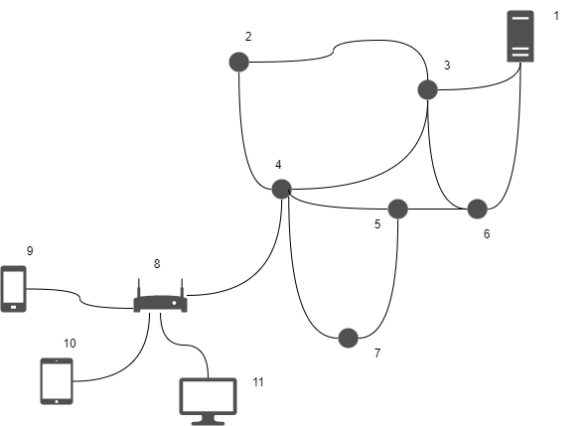
(a) Describe how packet switching is involved in sending data from the computer
(labelled 11) to the server (labelled 1). [4]

(b) A traditional telephone network established a telephone call by connecting dedicated lines together. The telephone customer then has exclusive use of all these lines when making their call.
Explain one advantage of using a packet switched network over a traditional
telephone network. [2]

[Total 10 marks]

